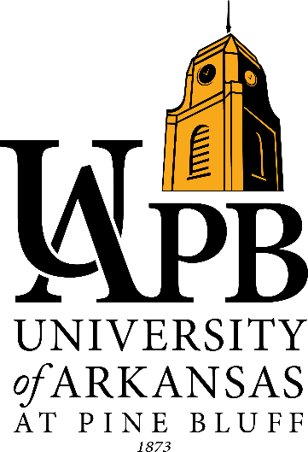
LION FEVER DAY
April 6, 2018
7:30 am-2:00 pm

Registration/Check- in 7:30 am- 9:00 am
Hathaway- Howard Fine Art Building
Campus Tour
(Academic Building, Student Union, Delta Housing Complex and STEM)

Departmental College Fair
(UAPB Departments, Admission, Financial Aid, LIONS Program & more)

Lunch (H.O. Clemmons Arena)
Provided by Super 1 Foods and Tyson Foods

Lion Fever Day Program (12 pm-2 pm)
(Scholarship Opportunities, Student Experience, Student Government Association, High School Mascot Competition and performance by the Musical Marching Machine of the Mid- South and the Golden Lion)

